Clustering Analysis-Based Identification of Key Indicators of Heart Disease Risk

III. Results and Analysis

# Correlation Analysis
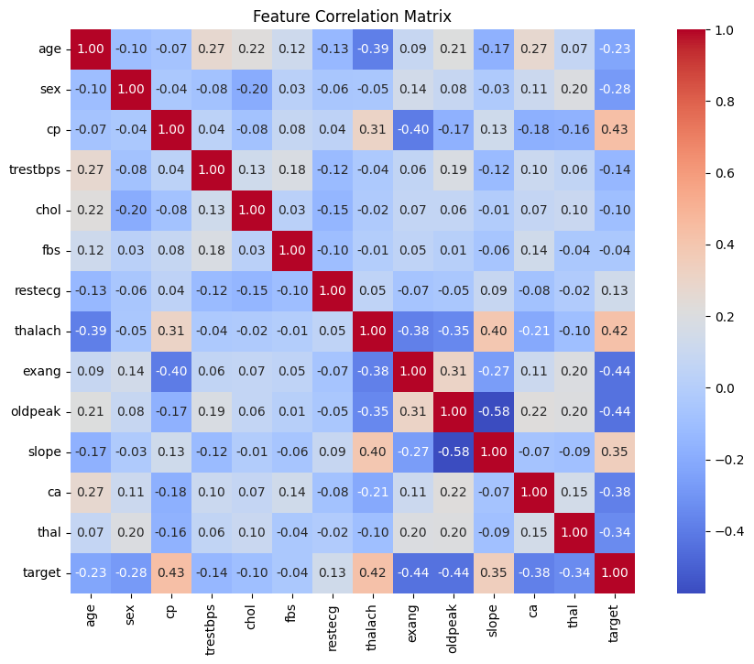
Rows and Columns: Each row and column represents a feature, such as age, sex, or chol (cholesterol).
- Colors: The colors show the strength of the connection:
  - Red = strong positive connection (when one increases, the other does too).
  - Blue = strong negative connection (when one increases, the other decreases).
  - Light colors = weak or no connection.
- Numbers: These range from -1 to 1:
  - 1.00 = perfect positive connection (seen on the diagonal where each feature meets itself).
  - -1.00 = perfect negative connection.
  - 0 = no connection.

The Features Involved
Here are the health factors (features) included in the matrix:
- age: Person’s age.
- sex: Male or female.
- cp: Chest pain type.
- trestbps: Resting blood pressure.
- chol: Cholesterol level.
- fbs: Fasting blood sugar (high or low).
- restecg: Resting electrocardiogram results.
- thalach: Maximum heart rate achieved.
- exang: Exercise-induced angina (chest pain during exercise, yes/no).
- oldpeak: ST depression (an ECG measurement).
- slope: Slope of the peak exercise ST segment (another ECG measure).
- ca: Number of major blood vessels colored by fluoroscopy.
- thal: Thalassemia (a blood disorder).
- target: Likely whether heart disease is present (the outcome we’re predicting).

Key Relationships to Understand
The matrix shows how these features relate. Here are the most important connections, especially with the target (heart disease):

Strong Connections with Heart Disease (Target)
- Negative Correlations (Blue):
  - exang (exercise-induced angina): -0.44 – People with chest pain during exercise are less likely to have heart disease here. (This might seem surprising, so it’s worth double-checking the data or how "target" is defined.)
  - oldpeak (ST depression): -0.44 – Higher ST depression links to a lower chance of heart disease.
  - ca (number of vessels): -0.44 – More colored vessels might mean better blood flow, reducing heart disease risk.
- Positive Correlations (Red):
  - cp (chest pain type): 0.43 – Certain types of chest pain strongly suggest heart disease.
  - thalach (max heart rate): 0.42 – Higher maximum heart rates are linked to a higher chance of heart disease.

Other Notable Relationships
- age and thalach: -0.39 – Older people tend to have lower maximum heart rates.
- slope and oldpeak: 0.58 – These ECG measures are strongly tied together.
- thalach and exang: -0.38 – Higher heart rates during exercise correlate with less chest pain.
Most other correlations are weaker (closer to 0), meaning those features don’t have a strong direct relationship.

Figure 1: Cluster Scatter-plot based on Age and Cholesterol Levels

A. Visualizations and Insights

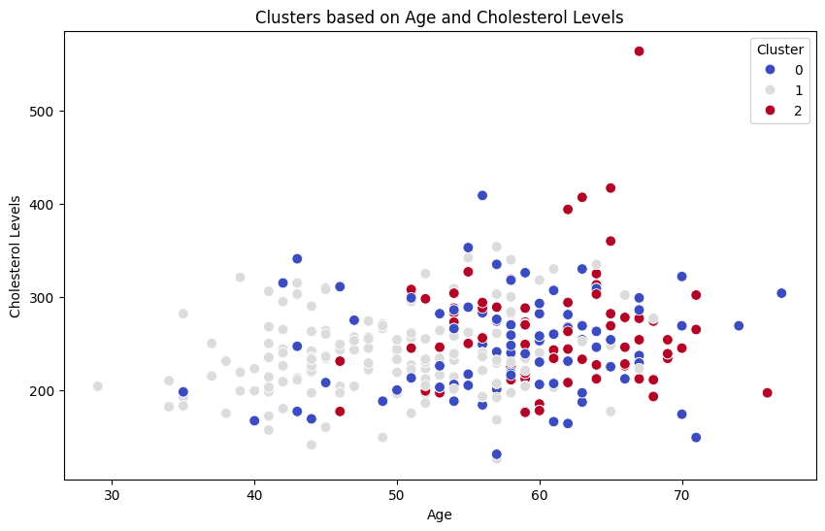
The clustering results for heart disease risk provide insightful segmentation of patients into three primary groups (clusters 0, 1, and 2). Here's a detailed significance analysis:
1. Cluster Sizes:
- Cluster 0: 396 individuals.
- Cluster 1: 287 individuals.
- Cluster 2: 342 individuals.
The distribution of cluster sizes is relatively balanced, offering a proportional representation of different risk patterns.
2. Mean Feature Values by Cluster:
- Cluster 0: Represents younger individuals (mean age of ~47.8), mostly males (~86.6%), with relatively normal or low cholesterol levels (mean ~227.9). These individuals exhibit higher maximum heart rates (mean ~164.98) and lower occurrences of exercise-induced angina (~12.6%). This cluster likely indicates a lower-risk group or individuals with generally healthier heart profiles.
-Cluster 1: Comprising individuals with a higher average age (~59.4) but a balanced distribution of males (~32%). Cholesterol levels are elevated (~259.8), suggesting a moderate-risk group. Notably, occurrences of exercise-induced angina are higher (mean ~15.3%), reflecting strain under physical activity.
- Cluster 2: Represents older individuals (mean age ~57.9), predominantly males (~80.9%). Cholesterol levels are high (~255.3), with significantly lower maximum heart rates (~129.8), higher scores for exercise-induced angina (~73.4%), and elevated oldpeak values (~1.99). This cluster likely reflects individuals with higher heart disease risk.
3. Health Risk Implications:
- Cluster 0: is indicative of a relatively low-risk demographic.
- Cluster 1: represents moderate-risk individuals where early medical intervention (lifestyle changes or monitoring) might significantly reduce further complications.
- Cluster 2: highlights a high-risk group needing immediate attention, including advanced medical tests and care.

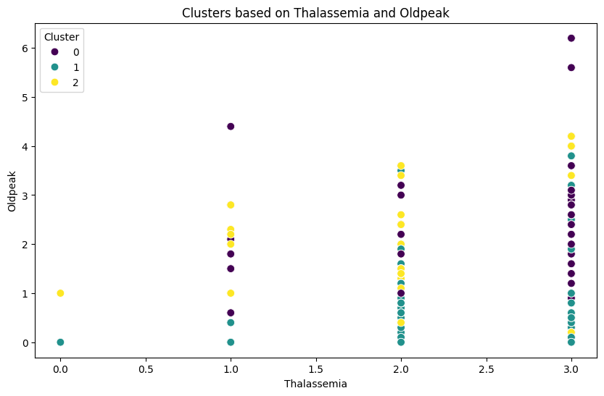
These findings create a foundation for developing targeted healthcare strategies and preventive measures by improving early diagnosis and understanding individual risk levels.

What the Plot Shows
The scatter plot visualizes clusters of data points based on two medical test results:
- X-axis (Thalassemia, labeled as "thal"): This refers to the results of a thallium stress test, which is used to evaluate blood flow to the heart. In this context, "thal" likely represents different categories of thallium test results (e.g., normal, fixed defect, reversible defect), which are often encoded as numerical values (0, 1, 2, etc.) in datasets like the UCI Heart Disease dataset.
- Y-axis (Oldpeak): This represents the ST depression induced by exercise relative to rest, measured in millimeters. ST depression is a finding on an electrocardiogram (ECG) that can indicate heart issues, such as ischemia (reduced blood flow to the heart). Higher values of oldpeak are generally associated with a higher risk of heart disease.
- Color-coded Clusters: The data points are grouped into three clusters (labeled 0, 1, and 2) and are color-coded:
  - Purple: Cluster 0
  - Cyan: Cluster 1
  - Yellow: Cluster 2

Interpretation of the Clusters
The caption below the plot explains that these clusters indicate varying risk patterns for heart disease, with a focus on how specific medical test results (thal and oldpeak) contribute to risk stratification. Here's what we can infer:
- Cluster 0 (Purple):
  - Most points in this cluster have a thalassemia value around 0.0 to 1.0 and oldpeak values ranging from 0 to 5.
  - This cluster likely represents a group with lower or moderate risk, as the oldpeak values are spread out but not consistently high, and the thalassemia values are on the lower end.
- Cluster 1 (Cyan):
  - These points are concentrated around a thalassemia value of 0.0 and have oldpeak values mostly between 0 and 1.
  - This cluster might represent a low-risk group, as both the thalassemia value (possibly indicating a normal thallium test result) and the low oldpeak values suggest minimal ST depression and thus lower heart disease risk.
- Cluster 2 (Yellow):
  - These points are mostly around a thalassemia value of 2.0 to 3.0, with oldpeak values ranging from 0 to 4, but many are on the higher side (around 2 to 4).
  - This cluster likely represents a higher-risk group. Higher thalassemia values (possibly indicating a reversible defect in the thallium test) combined with higher oldpeak values (indicating more significant ST depression) suggest an increased likelihood of heart disease.

Context of the Analysis
The project appears to be a heart disease risk classification study, likely using a dataset like the UCI Heart Disease dataset, which includes features such as thalassemia test results, oldpeak, and other clinical measurements. The clustering (possibly done using an algorithm like K-means) groups patients into categories based on these two features to identify patterns of risk. The caption emphasizes that higher oldpeak values and specific thalassemia categories (e.g., reversible defects) are markers for increased heart disease risk.

Key Takeaways
- Thalassemia and Oldpeak as Risk Indicators: The plot shows how these two features can be used to stratify patients into different risk groups. Higher values of oldpeak and certain thalassemia results (like 2 or 3) are associated with higher risk (Cluster 2).
- Clustering for Risk Stratification: The three clusters help differentiate between low, moderate, and high-risk groups based on these medical test results.
- Clinical Relevance: In a medical context, this type of analysis can help doctors identify patients who need more aggressive monitoring or treatment based on their test results.

Figure 2: Boxplot of Cholesterol Levels across Clusters

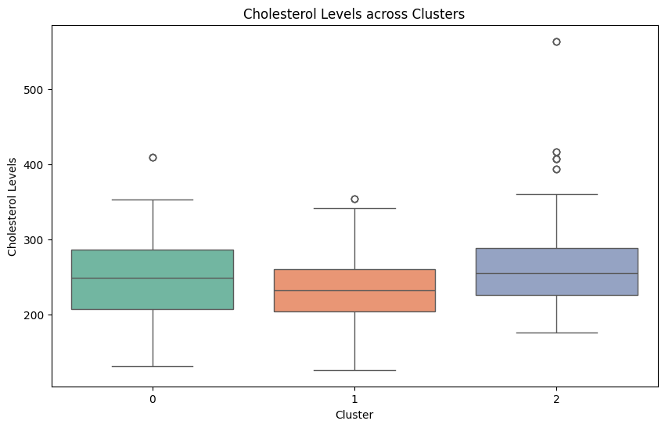
Interpreting the Boxplot
Let’s analyze each cluster:
- Cluster 0 (Green Box):
  - Median: Around 200 mg/dL.
  - IQR: The box spans roughly from 180 to 220 mg/dL, meaning the middle 50% of cholesterol levels in this cluster fall within this range.
  - Whiskers: Extend from about 150 to 250 mg/dL, showing the range of most data points.
  - Outliers: A few points above 400 mg/dL, indicating some individuals in this cluster have unusually high cholesterol.
- Cluster 1 (Orange Box):
  - Median: Around 250 mg/dL, higher than Cluster 0.
  - IQR: The box spans roughly from 220 to 280 mg/dL, showing more variability than Cluster 0.
  - Whiskers: Extend from about 180 to 320 mg/dL.
  - Outliers: A few points above 400 mg/dL, similar to Cluster 0.
- Cluster 2 (Blue Box):
  - Median: Around 230 mg/dL, between Clusters 0 and 1.
  - IQR: The box spans roughly from 200 to 260 mg/dL.
  - Whiskers: Extend from about 170 to 300 mg/dL.
  - Outliers: A few points above 400 mg/dL.

Key Observations
- Differences in Medians: Cluster 1 has the highest median cholesterol level (~250 mg/dL), followed by Cluster 2 (~230 mg/dL), and Cluster 0 (~200 mg/dL). This suggests that individuals in Cluster 1, on average, have higher cholesterol levels.
- Variability: Cluster 1 also shows the most variability (largest IQR), meaning cholesterol levels in this group are more spread out compared to Clusters 0 and 2.
- Outliers: All clusters have outliers above 400 mg/dL, indicating that each group has some individuals with extremely high cholesterol levels.
- Heart Disease Risk: The caption mentions that higher cholesterol values align with higher-risk groups for heart disease. Since Cluster 1 has the highest median cholesterol, it’s likely the highest-risk group for heart disease among the three.
The bar plot shows how many males and females are in each of three groups (clusters) of patients. These clusters (0, 1, and 2) were created earlier to group patients by their heart disease risk.

What the Plot Shows
- X-axis (Cluster): The three clusters (0, 1, and 2), which represent different levels of heart disease risk.
- Y-axis (Count): The number of patients in each cluster, ranging from 0 to 300.
- Bars:
  - Pink bars represent females.
  - Cyan (light blue) bars represent males.
- Each cluster has two bars: one for females and one for males, showing how many of each gender are in that cluster.

Breaking It Down Simply

1. The Clusters
From previous plots, we know:
- Cluster 0 (Cyan in earlier plots): Moderate risk.
- Cluster 1 (Pink in earlier plots): Low risk.
- Cluster 2 (Orange in earlier plots, Purple in some): High risk.

2. What the Bars Show
The bars show the number of males and females in each cluster:
- Cluster 0:
  - Females (pink): Around 50.
  - Males (cyan): Around 250.
  - Total: About 300 patients, mostly males.
- Cluster 1:
  - Females (pink): Around 150.
  - Males (cyan): Around 50.
  - Total: About 200 patients, mostly females.
- Cluster 2:
  - Females (pink): Around 100.
  - Males (cyan): Around 50.
  - Total: About 150 patients, more females than males but not as extreme as Cluster 1.

What This Means
- Cluster 0 (Moderate Risk): This group has way more males (250) than females (50). So, this moderate-risk group is mostly male.
- Cluster 1 (Low Risk): This group has more females (150) than males (50). So, the low-risk group is mostly female.
- Cluster 2 (High Risk): This group has more females (100) than males (50), but the difference isn’t as big as in Cluster 1. The high-risk group has a mix but leans toward females.

Why It Matters
The plot shows that gender might play a role in heart disease risk:
- Males dominate the moderate-risk group (Cluster 0), suggesting males might be more likely to have moderate risk in this dataset.
- Females dominate the low-risk group (Cluster 1), suggesting females might be more likely to have lower risk.
- The high-risk group (Cluster 2) has more females, but it’s more balanced, showing that both genders can be at high risk, though females are a bit more common here.
This helps doctors understand that gender could be a factor in heart disease risk. For example, in this dataset, males are more common in the moderate-risk group, while females are more common in the low-risk group.

Figure 3: Age Distribution across Clusters

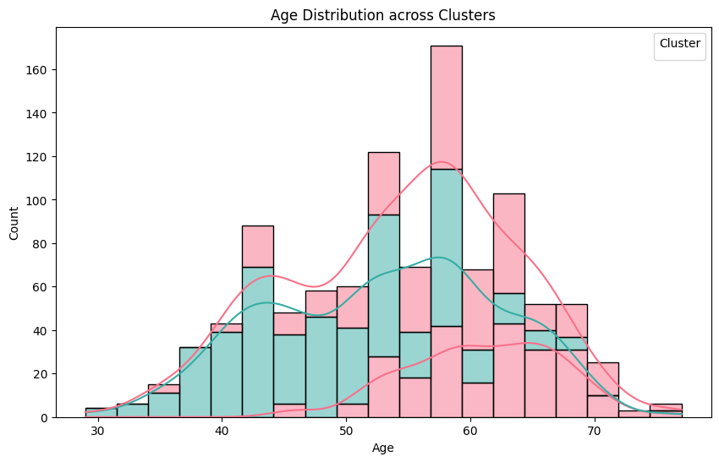

Understanding the Histogram
The histogram, titled "Age Distribution across Clusters," visualizes how ages are distributed within two groups (clusters) linked to heart disease risk. The x-axis shows ages from about 30 to 70, and the y-axis shows the count of people, up to 160.
- Cluster A (Pink): This cluster peaks at the 50-60 age group, meaning many people here are in their 50s and 60s.
- Cluster B (Light Green): This cluster has a more even distribution, with people spread across ages 40 to 70, from their 40s to 70s.

What This Means
- The histogram suggests that age plays a role in differentiating risk profiles. Older individuals (e.g., 50-60+) are more concentrated in one cluster, which could correlate with higher heart disease risk.
- The broader distribution in the teal cluster might indicate a more diverse age group with varying risk factors, possibly requiring further analysis with additional features (e.g., cholesterol levels, blood pressure).

Figure 4: Pairplot of Key Features Highlighting Clusters

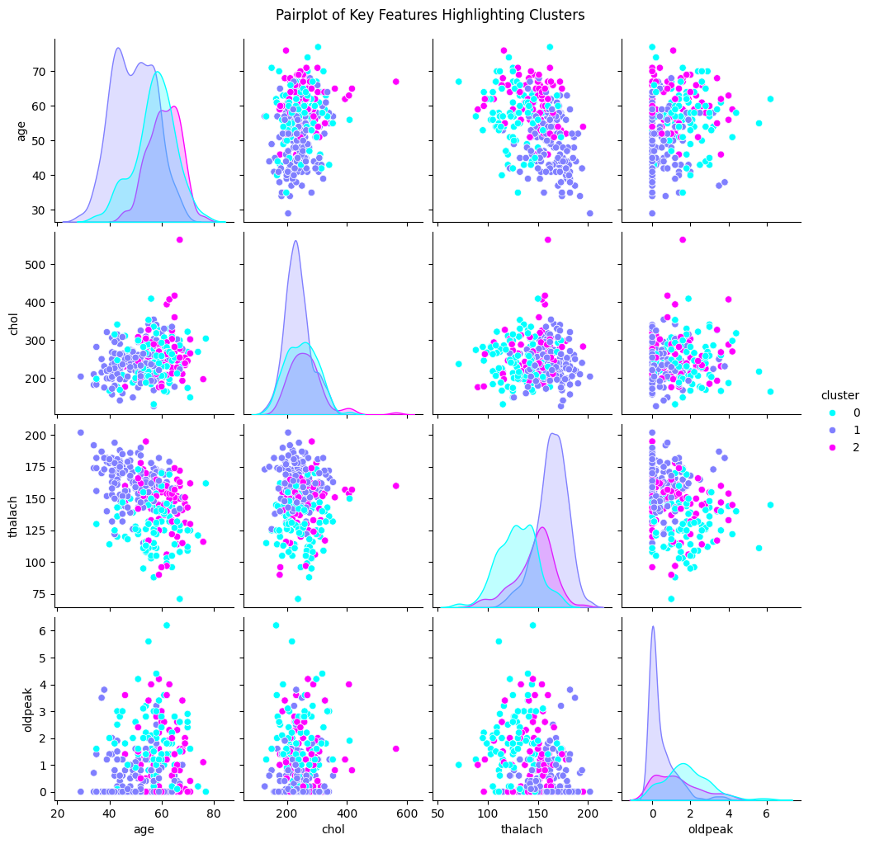

What the Pair-plot Shows
A pair-plot is like a grid of mini-charts. Each row and column represents one of the four features:
- Rows and Columns: Age, cholesterol, thalach, and oldpeak.
- Diagonal: These show the distribution (like a mini-histogram) of each feature for the three clusters.
- Off-Diagonal: These are scatter plots showing how two features relate to each other (e.g., age vs. cholesterol, cholesterol vs. thalach, etc.).
- Colors:
  - Cyan (light blue) for Cluster 0
  - Pink for Cluster 1
  - Purple for Cluster 2

Breaking It Down Simply

1. Diagonal (Distributions)
The diagonal plots show how each feature (age, cholesterol, thalach, oldpeak) is spread out for each cluster:
- Age: Cluster 0 (cyan) has more older people (around 50–70), Cluster 1 (pink) has younger people (around 40–60), and Cluster 2 (purple) has a mix of ages.
- Cholesterol (chol): Cluster 2 (purple) has higher cholesterol levels (around 200–350), while Cluster 1 (pink) has lower levels (around 150–300).
- Thalach: Cluster 0 (cyan) has higher thalach values (around 140–180), while Cluster 2 (purple) has lower values (around 100–150).
- Oldpeak: Cluster 2 (purple) has higher oldpeak values (around 0–4), while Cluster 1 (pink) has mostly lower values (around 0–1).

2. Off-Diagonal (Scatter Plots)
The scatter plots show how two features relate to each other for the three clusters:
- Age vs. Cholesterol: Cluster 2 (purple) often has higher cholesterol across all ages, while Cluster 1 (pink) has lower cholesterol, especially for younger people.
- Age vs. Thalach: Cluster 0 (cyan) has higher thalach values (better heart response to exercise) across ages, while Cluster 2 (purple) has lower thalach, especially for older patients.
- Cholesterol vs. Thalach: Cluster 2 (purple) tends to have higher cholesterol and lower thalach, a risky combination. Cluster 0 (cyan) has higher thalach and a range of cholesterol levels.
- Thalach vs. Oldpeak: Cluster 2 (purple) has lower thalach and higher oldpeak (a sign of heart stress), while Cluster 1 (pink) has higher thalach and lower oldpeak (less heart stress).

What This Means
- Cluster 0 (Cyan): Moderate risk. These patients are older, have moderate cholesterol, higher thalach (better heart response), and a range of oldpeak values.
- Cluster 1 (Pink): Low risk. These patients are younger, have lower cholesterol, higher thalach, and lower oldpeak (less heart stress).
- Cluster 2 (Purple): High risk. These patients have higher cholesterol, lower thalach (poorer heart response), and higher oldpeak (more heart stress), across a mix of ages.

Why It Matters
This pair-plot helps doctors see how these four factors (age, cholesterol, thalach, oldpeak) combine to show heart disease risk. For example, Cluster 2’s combination of high cholesterol, low thalach, and high oldpeak signals a higher risk, while Cluster 1’s younger age and better test results signal a lower risk.

# 5. Barplot showing the distribution of 'sex' across clusters

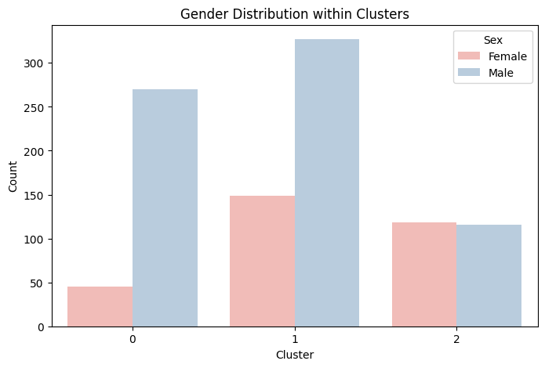
The bar plot shows how many males and females are in each of three groups (clusters) of patients. These clusters (0, 1, and 2) were created earlier to group patients by their heart disease risk.

What the Plot Shows
- X-axis (Cluster): The three clusters (0, 1, and 2), which represent different levels of heart disease risk.
- Y-axis (Count): The number of patients in each cluster, ranging from 0 to 300.

- Bars:
  - Pink bars represent females.
  - Cyan (light blue) bars represent males.
- Each cluster has two bars: one for females and one for males, showing how many of each gender are in that cluster.

Breaking It Down Simply

1. The Clusters
From previous plots, we know:
- Cluster 0 (Cyan in earlier plots): Moderate risk.
- Cluster 1 (Pink in earlier plots): Low risk.
- Cluster 2 (Orange in earlier plots, Purple in some): High risk.

2. What the Bars Show
The bars show the number of males and females in each cluster:
- Cluster 0:
  - Females (pink): Around 50.
  - Males (cyan): Around 250.
  - Total: About 300 patients, mostly males.
- Cluster 1:
  - Females (pink): Around 150.
  - Males (cyan): Around 50.
  - Total: About 200 patients, mostly females.
- Cluster 2:
  - Females (pink): Around 100.
  - Males (cyan): Around 50.
  - Total: About 150 patients, more females than males but not as extreme as Cluster 1.

What This Means
- Cluster 0 (Moderate Risk): This group has way more males (250) than females (50). So, this moderate-risk group is mostly male.
- Cluster 1 (Low Risk): This group has more females (150) than males (50). So, the low-risk group is mostly female.
- Cluster 2 (High Risk): This group has more females (100) than males (50), but the difference isn’t as big as in Cluster 1. The high-risk group has a mix but leans toward females.

Why It Matters
The plot shows that gender might play a role in heart disease risk:
- Males dominate the moderate-risk group (Cluster 0), suggesting males might be more likely to have moderate risk in this dataset.
- Females dominate the low-risk group (Cluster 1), suggesting females might be more likely to have lower risk.
- The high-risk group (Cluster 2) has more females, but it’s more balanced, showing that both genders can be at high risk, though females are a bit more common here.
This helps doctors understand that gender could be a factor in heart disease risk. For example, in this dataset, males are more common in the moderate-risk group, while females are more common in the low-risk group.

Figure 6. Scatterplot with Regression Line for Age vs Cholesterol across Clusters

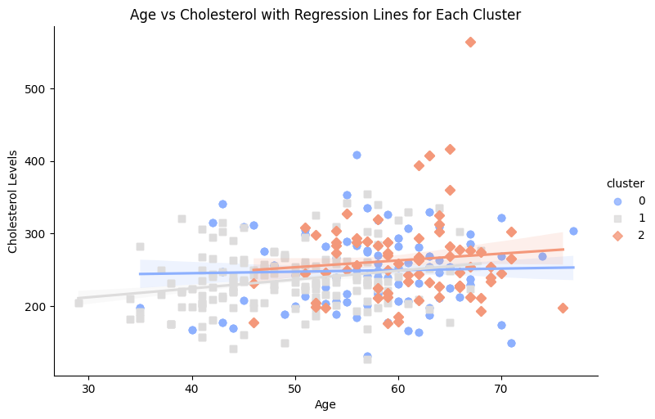
The plot is a scatter plot with regression lines, showing how age and cholesterol levels relate to each other across three groups (clusters) of patients. These clusters (0, 1, and 2) were created earlier to group patients by their heart disease risk.

What the Plot Shows
- X-axis (Age): The age of the patients, ranging from about 30 to 80 years.
- Y-axis (Cholesterol Levels): The cholesterol levels in milligrams per deciliter (mg/dL), ranging from about 100 to 500 mg/dL.
- Dots: Each dot represents a patient, with their age and cholesterol level.
Colors:
- Cyan (light blue) dots for Cluster 0
- Pink dots for Cluster 1
- Orange dots for Cluster 2
Lines: Each cluster has a line (called a regression line) that shows the general trend of how cholesterol changes with age for that group. The shaded area around each line shows the range of uncertainty.

Breaking It Down Simply
1. The Clusters
These clusters were made earlier based on things like heart test results (thalassemia and ST depression). From previous plots:
- Cluster 0 (Cyan): Moderate risk.
- Cluster 1 (Pink): Low risk.
- Cluster 2 (Orange): High risk.

2. What the Dots Show
The dots show each patient’s age and cholesterol level:
-Cluster 0 (Cyan): These patients are mostly older (50–70 years) and have cholesterol levels around 150–350 mg/dL.
-Cluster 1 (Pink): These patients are younger (40–60 years) and have lower cholesterol, mostly around 150–300 mg/dL.
-Cluster 2 (Orange): These patients have a mix of ages (40–70 years) but tend to have higher cholesterol, often around 200–400 mg/dL.

3. The Regression Lines
The lines show the trend of cholesterol as age increases for each cluster:
- Cluster 0 (Cyan Line): The line is pretty flat, meaning cholesterol doesn’t change much as age increases. It stays around 250 mg/dL.
- Cluster 1 (Pink Line): The line slopes slightly upward, meaning cholesterol increases a bit with age, but it stays lower (around 200–250 mg/dL).
Cluster 2 (Orange Line): The line also slopes slightly upward, but it’s higher up, meaning cholesterol is generally higher (around 250–300 mg/dL) and increases a little with age.

What This Means
-Cluster 0 (Moderate Risk): Older patients with steady cholesterol levels. Their risk isn’t driven by cholesterol increasing with age.
-Cluster 1 (Low Risk): Younger patients with lower cholesterol that rises slightly with age. Their lower cholesterol and younger age help keep their risk low.
-Cluster 2 (High Risk): Patients with higher cholesterol across all ages, and it increases a bit as they get older. High cholesterol is a big reason for their higher risk.
Why It Matters
This plot helps doctors see how age and cholesterol together affect heart disease risk. Cluster 2’s higher cholesterol across all ages shows why they’re at higher risk, while Cluster 1’s lower cholesterol and younger age show why they’re at lower risk.

